**Determining Potential Threats to *Acropora palmata* Reproductive Health in Salt River Bay National Historic Park and Ecological Preserve**

**ABSTRACT**

Populations of *Acropora palmata* (Elkhorn coral) were previously one of the most abundant reef building corals in the Caribbean, but they have declined more than 80% in the last 30 years. In addition to rising sea surface temperatures, ocean acidification, white band disease outbreaks and storms, coral face local anthropogenic pollution resulting in degraded water quality. The surviving *A. palmata* in Salt River Bay National Historic Park and Ecological Preserve (SARI) in St. Croix, USVI have shown reproductive impairment demonstrating almost no gonadal material from tissue biospsies, but coral that have been sampled at Buck Island Reef National Monument (BUIS), northeast of the St. Croix mainland, have a greater reproductive output at most sites. Poor reproductive capability could be attributed to pollution in the vicinity of SARI resulting in poor water quality. The purpose of this study is to: 1) quantify the presence of pollutants in Salt River Bay, 2) investigate the correlation of pollutants with *Acropora palmata* reproduction to assess their potential impact on coral health using both a field and laboratory-based approach, and 3) make inferences about potential sources of the pollutants from the surrounding watershed. To fulfill these objectives, an elemental analysis will be performed on two types of field samples from SARI and BUIS: coral skeletons and sediment. The elemental analysis will assist in determining sources and exposure, and if there is a correlation between metals, turbidity or other differences in water quality and the reproductive failure in the SARI *A. palmata* population. This study will also incorporate a coral toxicity bioassay in the lab to determine metal toxicity on coral health by measuring coral wound healing and the photosynthetic efficiency of the symbiotic dinoflagellates. Additionally, a FoRAM index will be implemented to evaluate ecological damage from contaminants at each site (SARI and BUIS). The integration of the various methods in this study will provide a diagnostic assessment of which stressors may be responsible for the observed reduction in *A. palmata* fecundity at St. Croix. This information will assist in implementing future management strategies regarding *A. palmata’s* preservation and recovery.

**PREDICTION**

Elemental pollutants from the Salt River watershed are impacting *Acropora palmata* reproductive health.

**METHODS**

***Collection Sites***

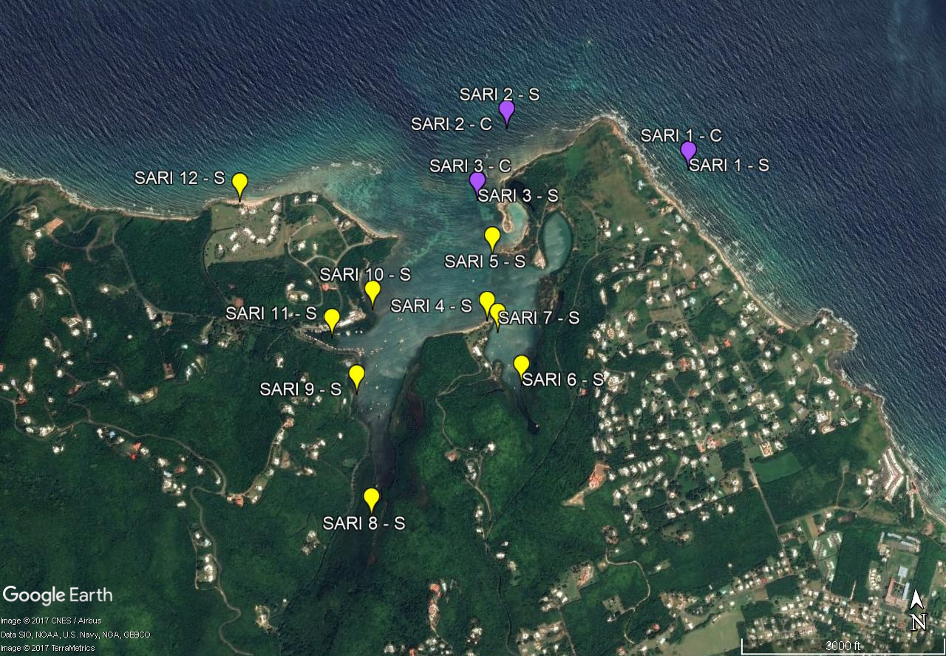

**Salt River Bay**

Figure 1. Sampling locations in Salt River Bay National Historic Park and Ecological Preserve. Sediment sample locations are labeled SARI - S (sites=12) and coral sampling locations are labeled SARI - C (sites=3). Sites where only sediment was sampled are demarcated in yellow and sites where both coral and sediment were sampled are demarcated in purple.

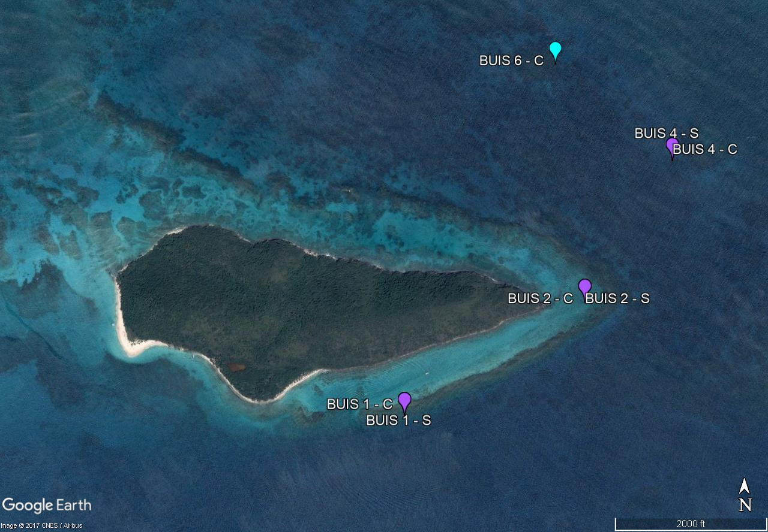

**Buck Island**

Figure 2. Sampling locations in Buck Island Reef National Monument (BUIS). Sediment (- S) and coral (- C) samples were taken from the same locations demarcated in purple (BUIS 1, BUIS 2, and BUIS 4). BUIS 6 - C, demarcated in blue, was solely a coral sampling location (BUIS coral: sites=4, BUIS sediment: sites=3).

***Coral Collection***

Biopsies of *Acropora palmata* were collected via SCUBA using a stainless steel hammer and chisels (1.5 cm). Chisels were pre-cleaned with isopropanol and Milli-Q water. A clean chisel and gloves were used for each biopsy to prevent cross-contamination between colonies. Target biopsy size was 2 cm in diameter and 1-2 cm in depth. Location of the biopsies on the colony was on the upward facing surface of the branches, at least 2 cm away from the growing edges, and on a sturdy portion of the branch that could withstand chiseling without breakage. Percent mortality and colony length of the *A. palmata* colonies was recorded at the time the biopsies were taken. Biopsies were placed into a plastic WhirlPak bag underwater. Immediately upon reaching the surface, the biopsies were transferred into Teflon jars and placed into liquid nitrogen (LN2). Samples were subsequently transferred into a -40°C freezer for storage. Coral biopsies were collected July 25-27th, 2017 from 7 sites with biopsies from 10 different colonies at each site (except at BUIS 4 where only 4 colonies were sampled) for a total of 64 coral samples (Figures 4 & 5). The GPS coordinates of the coral samples are listed in Table 1.

**Table 1. GPS coordinates of coral samples**

|  |  |  |
| --- | --- | --- |
| **Site** | **Latitude** | **Longitude** |
| SARI 1 | N 17°46.873 | W 64°44.707 |
| SARI 2 | N 17°47.003 | W 64°45.180 |
| SARI 3 | N 17°46.824 | W 64°45.268 |
| BUIS 1 | N 17°46.994 | W 64°36.989 |
| BUIS 2 | N 17°47.241 | W 64°36.576 |
| BUIS 4 | N 17°47.553 | W 64°36.371 |
| BUIS 6 | N 17.79612 | W 64.61066 |

***Sediment Collection***

The first few centimeters of sediment at each site were collected for element analysis using acid washed 50 mL polypropylene tubes. The tubes were immediately placed into a cooler and then frozen at -20°C. Sediment samples were later transferred to a -80°C freezer. Sediment was collected July 25-27th, 2017 from 15 different sites with 3 replicates at each site for a total of 45 sediment samples (Figures 4 & 5). The GPS coordinates of the sediment samples are listed in Table 2.

**Table 2. GPS coordinates of sediment samples**

|  |  |  |
| --- | --- | --- |
| **Site** | **Latitude** | **Longitude** |
| SARI 1 | N 17°46.597 | W 064°44.595 |
| SARI 2 | N 17°47.010 | W 064°44.908 |
| SARI 3 | N 17°46.735 | W 064°45.386 |
| SARI 4 | N 17°46.521 | W 064°45.260 |
| SARI 5 | N 17°46.682 | W 064°45.237 |
| SARI 6 | N 17°46.358 | W 064°45.180 |
| SARI 7 | N 17°46.490 | W 064°45.234 |
| SARI 8 | N 17°46.054 | W 064°45.584 |
| SARI 9 | N 17°46.356 | W 064°45.608 |
| SARI 10 | N 17°46.564 | W 064°45.557 |
| SARI 11 | N 17°46.499 | W 064°45.666 |
| SARI 12 | N 17°46.852 | W 064°45.893 |
| BUIS 1 | N 17°46.994 | W 064°36.989 |
| BUIS 2 | N 17°47.241 | W 064°36.576 |
| BUIS 4 | N 17°47.553 | W 064°36.371 |

***Coral Sample Preparation***

A stainless steel cryomill was used to grind the coral skeleton into a homogenous fine powder. Subsamples of the frozen powder, 150 mg, were further cleaned using Optima™ sodium hypochlorite, lab grade bleach, to remove coral tissue. The coral subsample was submerged in 4 ml of the bleach and the samples were mixed on a Scientific Industries, INC Roto-Shake Genie (Model No. SI-1100) for 66 hours. After the tissue and bleach supernatant was removed from the vials, 4 ml of high purity milli-Q water were added to rinse the skeleton. Vials were vortexed to re-suspend the skeleton. The milli-Q water rinsing and removal was repeated to obtain 3 rinses. After rinsing, the bleached coral powder was frozen at -80°C, lyophilized and stored at 4ºC until further processing. Before analysis, samples were dissolved in 50 ml of Fisher Optima™ 0.5M nitric acid (HNO3) according to NIST technical procedure TP 646.07.158 (Oxidative Cleaning and Dissolution of Carbonate Samples for Boron Isotope and Trace Element Analyses).

***Sediment Sample Preparation***

The sediment was brought to -80°C and then lyophilized in the original 50 mL sample collected jar, followed by a transfer to 125 mL acid washed polyethylene jars for additional lyophilization. Sediments were weighed periodically until the mass did not change by more than 0.5% in a week to indicate the sediment had dried. After freeze-drying, the sediment was placed in 4°C until further processing. Prior to sieving, a subsample of the sediment was removed for the FoRAM index (see below). Sediments were then coarsely sieved at 1 mm with a #18 3 inch stainless steel Cole Palmer sieve and a vortex to remove very course shell, rocks, sticks and leaves, which were non-target components of the analysis. The bottom of the sieve tray was pressed down onto a conical tube setting on the vortex for 30 seconds. A grain size analysis will be performed using a Malvern Mastersizer 3000 (Malvern, c2017). The instrument uses laser diffraction, which measures the angle of the scattered laser beam after the beam comes in contact with the particle. The angle of scattered light, which is inversely proportional to the particle size, is used to calculate particle volume from the Mie theory. Average particle size for each sample will be used to determine sediment classification (USDA, 1987). The sediment digestion was performed using the optimized digestion procedure, according to Durand et al. (2016). This optimized digestion procedure minimizes precipitation of calcium fluoride, which is formed when HF is added to the calcium carbonate (CaCO3) rich samples. Initially, 200 mg of sediment was weighed into a microwave vessel, the vessel was spiked with 200 mg of internal standard and 4 mL of hydrochloric acid (HCl) were added to each sample. All masses were measured gravimetrically. Microwave vessels were placed on a hot block at 150°C for 2 hours to assist in dissolving carbonates. Next, 2 mL of hydrofluoric acid (HF) and 10 mL of HNO3 were added to the samples followed by a microwave digestion using a CEM MarsXpress Xtraction microwave. Samples remained in the microwave overnight to cool down. The samples were then uncapped and placed back on the 150°C hot block to evaporate the HF. After being on the hot black for about 6 hours, an additional 4 mL of HNO3 was added to each sample. Vessels were removed and capped after about 20 hours. Quantitative mass transfers were performed on digested samples using HNO3 and by transferring contents from the microwave vessel to acid washed 50 mL polypropylene tubes. A subsequent 200 mg to 50 g dilution or 5 g to 50 g dilution was performed on all samples with the dilution depending on initial sample screens examining detection limits.

***Coral Skeleton and Sediment ICP-MS Materials and Settings***

The internal standard solution spiked into all samples, blanks and calibrations curves contained 3124a Indium (In) Standard Solution, 3148a Scandium (Sc) standard solution, 3121 Gold (Au) Standard Solution, and 3167a Yttrium (Y) Standard Solution. Final concentrations were reported using In as the internal standard for the no gas and helium mode and Y for the oxygen mass shift mode (Table 3). Calibration curves were gravimetrically prepared using NIST Standard Reference Material® (SRM) 1643f Trace Elements in Water and NBF+. The NBF+ is a multi-element matrix of standard solutions which was previously gravimetrically prepared (TP 646.07.001; Calibration and Use of Analytical Balances) from single element 3100 series NIST SRM and High Purity elements. The 1643f SRM contains concentrations of elements similar to those that would be found in estuary sediment, so the 1643f SRM calibration curve was used to determine sediment elemental concentrations. The NBF+ is similar to a coral matrix and was used to determine elemental concentrations in the coral skeletons. The controls used for the sediment analysis were NIST Standard Reference Material® 2702 Inorganics in Marine Sediment and NIST Standard Reference Material® 1944 New York/New Jersey Waterway Sediment. The controls used for measuring coral skeleton were NIST Candidate Reference Material 8301C Boron Isotopes in Marine Carbonate and AIST Certified Geochemical Reference Material JCp-1 Coral.

Coral skeleton and sediment samples were analyzed on the Thermo Element XR, a high-resolution sector field inductively coupled plasma mass spectrometer (ICP-MS), which was used for a multi-elemental analysis. The instrument was tuned prior to analysis in accordance with the recommendations in TP 646.07.141 (Setup and Optimization of High Resolution ICP-MS). Elements analyzed included Ca, Li, B, Al, P, V, Cr, Mn, Co, Ni, Cu, Zn, Rb, Mo, Ag, Cd, Sn, Sb, Cs, Ba, Nd, W, Pb, U, Na, Mg, Fe, Sr. In order to successfully capture concentrations for each element, the instrument was programmed to individually measure multiple isotopes for certain elements. All elements were measured using helium (He) gas mode but some elements were measured using additional modes, which were no gas mode and oxygen (O2) mass shift mode (Table 3). While the He no gas mode is a standard gas used for trace element measurements, the no gas mode can be helpful for elements that scatter and become undetectable when He is used. The O2 mass shift mode was used on elements that tend to produce oxides which would make them undetectable when the detector scans for their elemental mass.

**Table 3. Modes programmed for the initial analysis of each element.**

|  |  |  |  |  |  |  |  |
| --- | --- | --- | --- | --- | --- | --- | --- |
| **Mode** | **Mass Change** | **Atomic Mass** | **Element** | **Mode** | **Mass Change** | **Atomic Mass** | **Element** |
| 1: No Gas | 6 -> 6 | 6 | Li | 2: He | 111 -> 111 | 111 | Cd |
| 1: No Gas | 7 -> 7 | 7 | Li | 2: He | 112 -> 112 | 112 | Cd |
| 1: No Gas | 9 -> 9 | 9 | Be | 2: He | 113 -> 113 | 113 | In |
| 1: No Gas | 10 -> 10 | 10 | B | 2: He | 114 -> 114 | 114 | Cd |
| 1: No Gas | 11 -> 11 | 11 | B | 2: He | 118 -> 118 | 118 | Sn |
| 1: No Gas | 113 -> 113 | 113 | In | 2: He | 120 -> 120 | 120 | Sn |
| 2: He | 6 -> 6 | 6 | Li | 2: He | 121 -> 121 | 121 | Sb |
| 2: He | 7 -> 7 | 7 | Li | 2: He | 123 -> 123 | 123 | Sb |
| 2: He | 9 -> 9 | 9 | Be | 2: He | 125 -> 125 | 125 | Te |
| 2: He | 10 -> 10 | 10 | B | 2: He | 128 -> 128 | 128 | Te |
| 2: He | 11 -> 11 | 11 | B | 2: He | 133 -> 133 | 133 | Cs |
| 2: He | 23 -> 23 | 23 | Na | 2: He | 137 -> 137 | 137 | Ba |
| 2: He | 24 -> 24 | 24 | Mg | 2: He | 138 -> 138 | 138 | Ba |
| 2: He | 25 -> 25 | 25 | Mg | 2: He | 146 -> 146 | 146 | Nd |
| 2: He | 26 -> 26 | 26 | Mg | 2: He | 182 -> 182 | 182 | W |
| 2: He | 27 -> 27 | 27 | Al | 2: He | 184 -> 184 | 184 | W |
| 2: He | 31 -> 31 | 31 | P | 2: He | 197 -> 197 | 197 | Au |
| 2: He | 39 -> 39 | 39 | K | 2: He | 203 -> 203 | 203 | Tl |
| 2: He | 43 -> 43 | 43 | Ca | 2: He | 205 -> 205 | 205 | Tl |
| 2: He | 44 -> 44 | 44 | Ca | 2: He | 206 -> 206 | 206 | Pb |
| 2: He | 45 -> 45 | 45 | Sc | 2: He | 207 -> 207 | 207 | Pb |
| 2: He | 51 -> 51 | 51 | V | 2: He | 208 -> 208 | 208 | Pb |
| 2: He | 52 -> 52 | 52 | Cr | 2: He | 209 -> 209 | 209 | Bi |
| 2: He | 53 -> 53 | 53 | Cr | 2: He | 235 -> 235 | 235 | U |
| 2: He | 54 -> 54 | 54 | Fe | 2: He | 238 -> 238 | 238 | U |
| 2: He | 55 -> 55 | 55 | Mn | 3: O2 | 27 -> 43 | 27 | Al |
| 2: He | 56 -> 56 | 56 | Fe | 3: O2 | 31 -> 47 | 31 | P |
| 2: He | 57 -> 57 | 57 | Fe | 3: O2 | 45 -> 61 | 45 | Sc |
| 2: He | 59 -> 59 | 59 | Co | 3: O2 | 51 -> 67 | 51 | V |
| 2: He | 60 -> 60 | 60 | Ni | 3: O2 | 54 -> 70 | 54 | Fe |
| 2: He | 62 -> 62 | 62 | Ni | 3: O2 | 56 -> 72 | 56 | Fe |
| 2: He | 63 -> 63 | 63 | Cu | 3: O2 | 57 -> 73 | 57 | Fe |
| 2: He | 64 -> 64 | 64 | Zn | 3: O2 | 75 -> 91 | 75 | As |
| 2: He | 65 -> 65 | 65 | Cu | 3: O2 | 78 -> 94 | 78 | Se |
| 2: He | 66 -> 66 | 66 | Zn | 3: O2 | 80 -> 96 | 80 | Se |
| 2: He | 68 -> 68 | 68 | Zn | 3: O2 | 86 -> 102 | 86 | Sr |
| 2: He | 75 -> 75 | 75 | As | 3: O2 | 88 -> 104 | 88 | Sr |
| 2: He | 85 -> 85 | 85 | Rb | 3: O2 | 95 -> 111 | 95 | Mo |
| 2: He | 86 -> 86 | 86 | Sr | 3: O2 | 98 -> 114 | 98 | Mo |
| 2: He | 87 -> 87 | 87 | Rb | 3: O2 | 121 -> 137 | 121 | Sb |
| 2: He | 88 -> 88 | 88 | Sr | 3: O2 | 123 -> 139 | 123 | Sb |
| 2: He | 89 -> 89 | 89 | Y | 3: O2 | 125 -> 141 | 125 | Te |
| 2: He | 95 -> 95 | 95 | Mo | 3: O2 | 128 -> 144 | 128 | Te |
| 2: He | 98 -> 98 | 98 | Mo | 3: O2 | 146 -> 162 | 146 | Nd |
| 2: He | 107 -> 107 | 107 | Ag | 3: O2 | 235 -> 251 | 235 | U |
| 2: He | 109 -> 109 | 109 | Ag | 3: O2 | 238 -> 254 | 238 | U |

***Sediment Samples for ICP-MS Analysis (need figure)***

The sediment was measured in 2 different runs on the ICP-MS due to sediment digestion resources. Half of the sites were measured in each run and each run contained 3 blocks of samples. Since there were 3 replicates of sediment from each site, one replicate was placed in each block to prevent instrument drift bias. Each block also contained a blank instrument background sample made up of 2% high purity HNO3, calibration curves and SRMs. Additionally, 5 processing blanks were run in the first block to capture any sample contamination throughout digestion and handling.

***Coral Samples for ICP-MS Analysis (need figure)***

Coral was measured in a single run on the ICP-MS and the run contained 4 blocks. Each block contained a blank instrument background sample made up of 2% high purity HNO3, the NBF+ calibration curve, coral SRMs and randomly placed unknown coral samples. Additionally, 5 sample blanks were run in the first block.

***Data Processing and Statistical Analysis***

The internal standard concentrations and dilution factors for each sample were calculated offline and entered into the MassHunter 2.0 software to obtain final concentrations. The concentrations obtained for the SRMs were compared to their certificate values to assist in determining the most appropriate isotope and instrument mode to use for each element for reporting concentrations in the unknown samples. An instrument background subtraction was performed on all samples in the software and the most recently measured instrument background in the sample cue was used for subsequent samples. The sample blanks were examined for contamination and an additional subtraction was performed on all samples for any elements exhibiting substantial contamination in the blanks.

Almost all elements displayed non-normally distributed data, which was confirmed by running a Shapiro-Wilks Normality Test. A non-parametric Kruskal-Wallis Test was used on each element to test for significantly different concentrations in Salt River sediment when compared to Buck Island sediment. The Kruskal-Wallis test was also used to compare element concentrations found in the Salt River coral population to the Buck Island coral population. A Dunn’s Test using the Bonferroni correction method was run to compare individual element concentrations across all sites. Dunn’s test was used for both sediment and coral skeleton comparisons when examined across sites. Percent mortality and colony length of the *A. palmata* colonies, which was recorded at the time the biopsies were taken, were examined across sites and statistically analyzed using the same non-parametric tests described for the elements in coral and sediment.

**RESULTS**

***Sediment***

For the sediment samples, elements showing significant differences between SARI and BUIS were phosphorus (P), barium (Ba), zinc (Zn), lead (Pb) and boron (B). All elements were significantly greater in the SARI sediment.

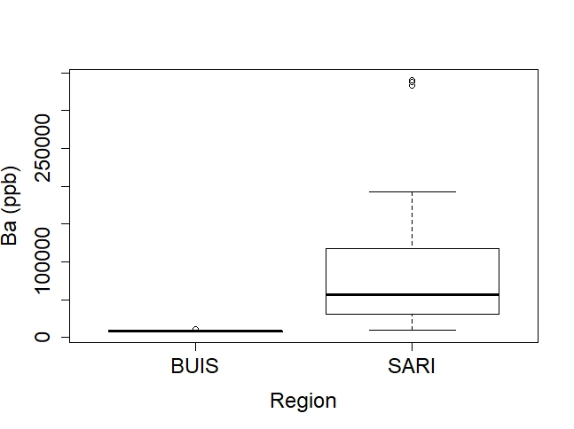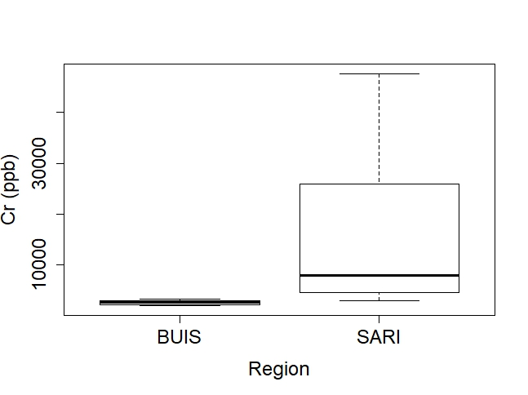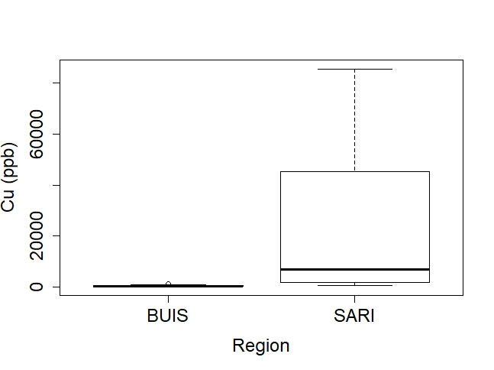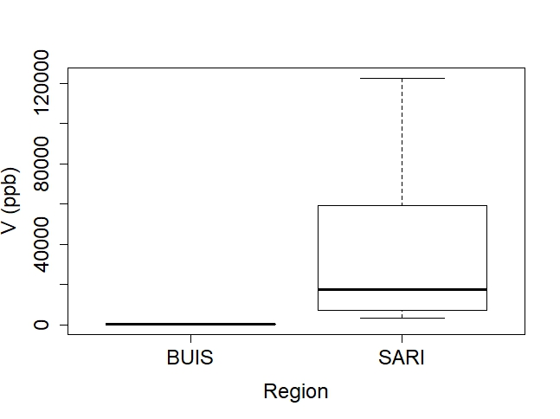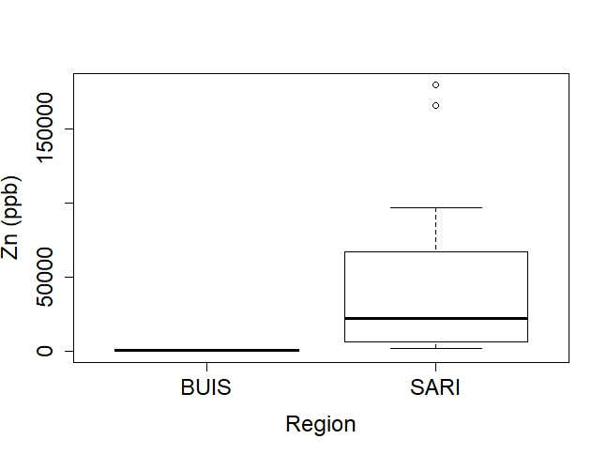

Figure 3. Elements measured in the sediment showing significant differences when comparing the BUIS region to the SARI region.

***Coral***

Overall, the goal was to compare the differences in coral between SARI and BUIS, but also to more closely examine elements by site that did not show that the concentrations were significantly different between SARI and BUIS when comparing the whole population. The SARI *A. palmata* population contained higher concentrations of iron (Fe), zinc (Zn) and lead (Pb) while the BUIS *A. palmata* population contained higher concentrations of boron (B), barium (Ba), and phosphorus (P) in their skeleton.

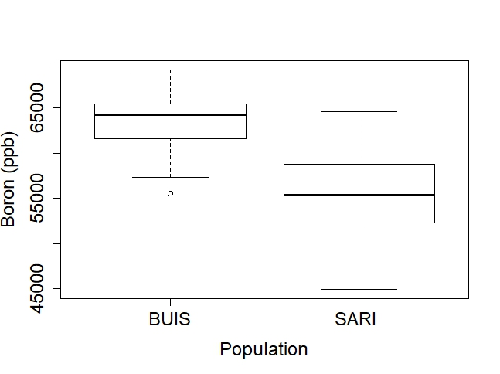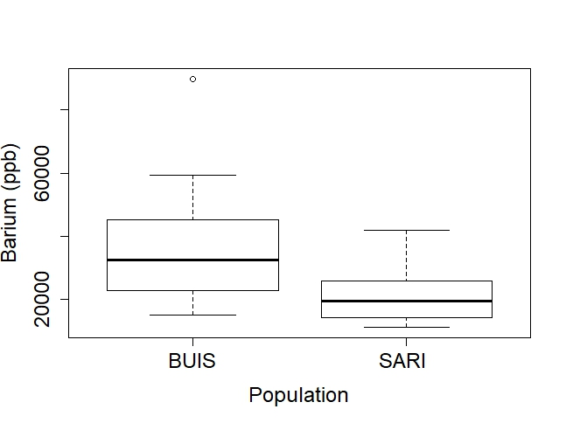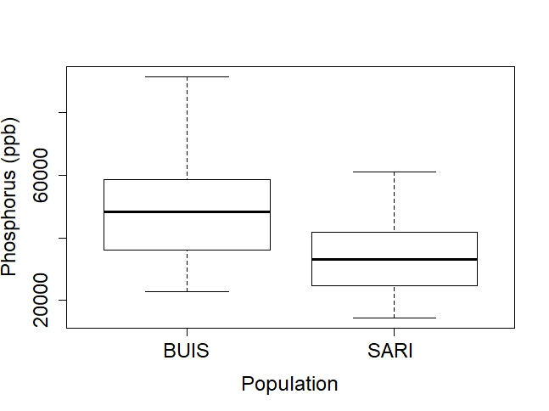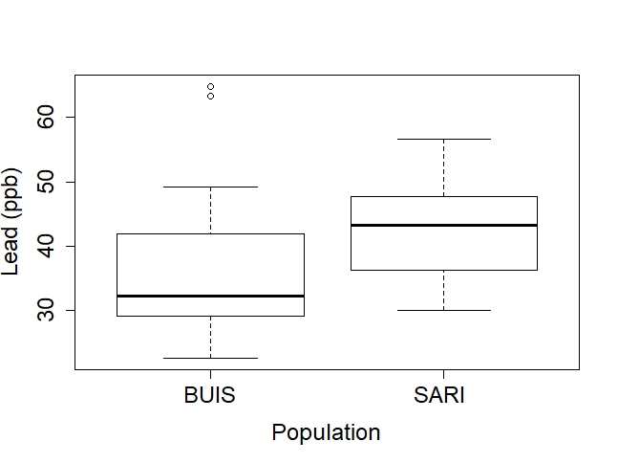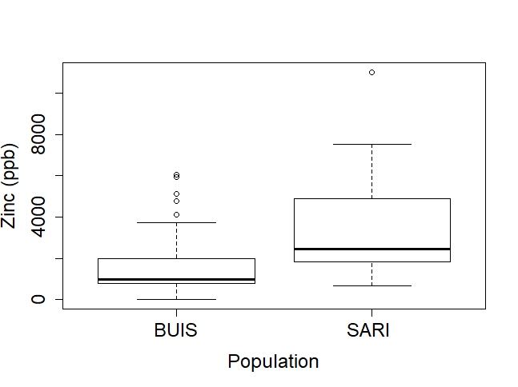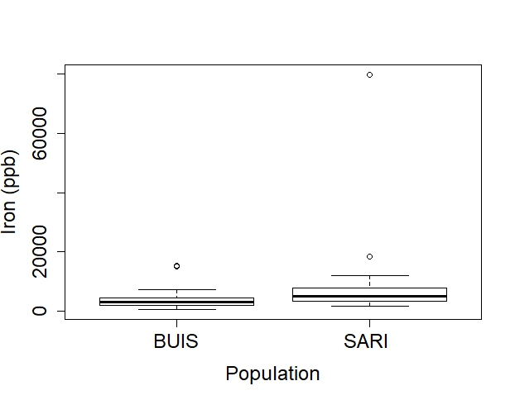

Figure 4. Elements in coral colonies showing significant differences when comparing the BUIS *A. palmata* coral population to the SARI *A. palmata* population.

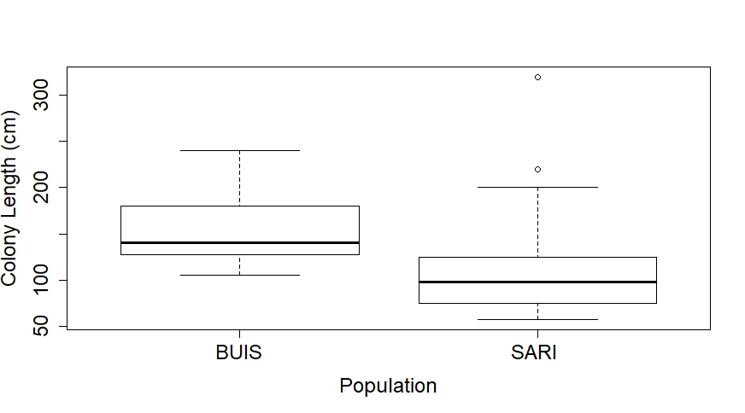

Figure 5. Colony length was significantly different between BUIS and SARI coral populations.

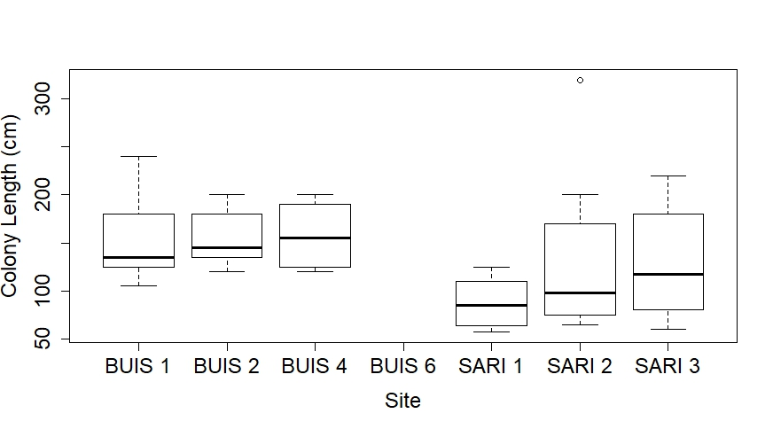

Figure 6. Coral colony length by site. SARI 1 was significantly different than BUIS 1 and BUIS 2.

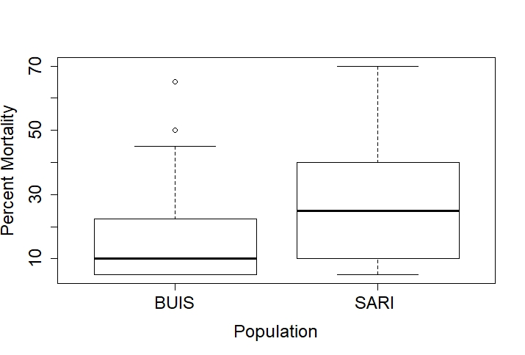

Figure 7. Mortality was not significantly different by population**.**

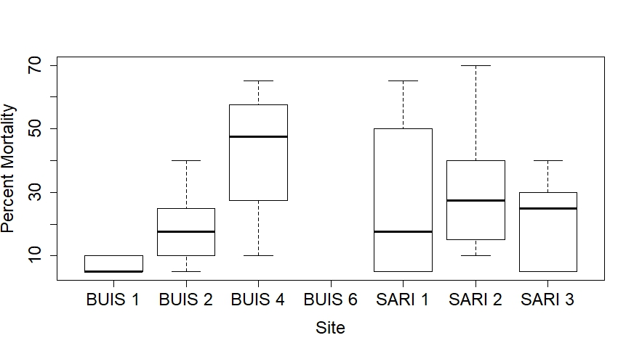

Figure 8. SARI 2 and BUIS 4 have significantly greater mortality than BUIS 1.

**INTERPRETATION**

The elemental analysis revealed that Salt River sediment contains a significantly greater amount of metals than Buck Island Sediment. Salt River Bay has very fine grain sediment derived from mangroves, thus it contains a large amount of organic content. The fine grains provide a greater surface area and the organic matter provides a sticky surface to which metals readily adsorb. Thus Salt River is a reservoir for metals and toxic compounds, but the main concern is coral exposure. Examining the elemental concentrations in the coral skeletons illuminates some of the toxic metals and water quality parameters the coral are being exposed to. Since Fe was significantly greater in the SARI coral population, this indicates that the coral near Salt River are being exposed to more sediment. Iron adsorbs to coral skeletons but does not seem to accumulate inside the coral aragonite lattice (Inoue et al., 2014). The presence of Fe in the skeleton is most likely not a result of offloading but of sediment adsorption. The fine grains at Salt River may be easily re-suspended making the water around Salt River more turbid. Turbid water can be harmful to the coral, because the turbidity attenuates the light available to the symbiotic algae (dinoflagellates) which reside in coral and provide the coral with nutrients (Rogers, 1979). Padilla-Gamino et al. (2014) examined oocyte number and size within coral polyps at three sites in Hawaii with different sedimentation rates. The sedimentation was not significantly correlated to oocyte number but was negatively correlated with oocyte size. A number of other environmental parameters were measured during the experiment and oocyte size was most correlated with solar radiation. With high enough sedimentation rates, the sediment may obscure a significant amount of solar radiation. Additionally, Diuron, an algicide and herbicide, has been shown to significantly reduce lipid content in *Acropora* species and significantly reduced polyp fecundity (measured as number of eggs per polyp) in *Acropora valida* (Cantin et al., 2007). The reduced lipid content is likely caused by the reduction in photosynthetic energy production, which may cause the subsequent decline in fecundity (Cantin et al., 2007). These studies emphasize the important role zooxanthellae play supplying nutrients to coral and how damaged or shaded zooxanthellae might subsequently effect coral health and reproduction.

Zinc was significantly greater in the sediment and the coral at Salt River. Reichelt-Brushett (2003) used a technique to separate eggs and sperm from the polyp in order to measure metal concentrations being transferred to the eggs and the sperm. They saw high concentrations of zinc (up to 69 µg/g or 69 ppm) in the eggs and the sperm which were even greater than the tissue and skeleton they measured. The concentration they found in the eggs and sperm is also greater than the coral skeleton concentration in the present study. This could have many implications depending on the success of reproduction. A lack of reproductive output could indicate the eggs and sperm were receiving too much Zn during offloading or that the corals now have no way to offload the Zn. During their lack of reproductive effort, more Zn may be offloaded into the skeleton.

Phosphorus was higher in the coral at Buck Island. Salt River has agricultural runoff but there are two potential sources of phosphorus contributing to the greater concentration at Buck Island. Buck is uninhabited but has a large migratory bird population. Additionally, studies have shown the effects the Amazon River has on the Caribbean as the freshwater plume travels up the coast of South America in the South Equatorial Current and then continues into the Caribbean Current. Climatology maps and data show the specific island mass effect that occurs on St. Croix after the flooded season (Figures 9, 10 & 11). Salinity clearly decreases during the month shown and the lower salinity plume does not look like it reaches Salt River but may be impacting Buck Island (Figures 10 & 11). 

Figure 10. Mean surface salinity around St. Croix during September 1st – 23rd in 2007. The salinity shown by color is overlaid with mean velocity vectors (Chérubin and Garavelli, 2016)

Figure 9. Salinity changes during the climatological year (Chérubin and Garavelli, 2016).



Figure 11. Mean surface salinity around St. Croix during August 1st – 20th in 2007. The salinity shown by color is overlaid with mean velocity vectors (Chérubin and Garavelli, 2016).

Since this plume is coming from the Amazon, it contains high concentrations of nutrients which could result in spikes of phosphorus being taken up in the coral skeletons at Buck Island. Another indication that Buck Island is being impacted by the Amazon River is the significantly greater concentration of Ba present in the coral skeletons. Higher concentrations of barium (Ba) can indicate greater freshwater input via river discharge (Moyer et al., 2012). The barium to calcium (Ca) ratio (Ba/Ca) can be compared to the strontium (Sr) to calcium ratio (Sr/Ca) to examine exposure to freshwater vs saltwater, respectively (Macdonald and Crook, 2010).

Since, B was greater in the coral skeleton at Buck Island, we can assume that the Buck Island coral are exposed to higher pH, lower pCO2, than the coral at Salt River. Boron is a proxy for pH and some studies have attempted to correlate pCO2 to the B concentration measured within the skeleton (Sanyal et al., 2000). While there appears to be no studies assessing the fecundity of coral with varying pH, low pH has been shown to effect fertilization efficiency in *A. palmata* depending on the sperm concentration (Albright, 2011). Therefore, low pH has been shown to be harmful to corals but the direct effect of pH on gamete production is unknown.

The sediments at Salt River contained higher concentrations of Cu, Cr and Zn and the coral at Salt River contained higher concentrations of Pb. These metals are widely used in urban and residential areas include siding material for buildings, (which contains high levels of Pb, Cu, Cd, Zn), vehicle brake emissions, (which contains Cu), and byproducts of tire wear (which contains Zn from the ZnO used in tire production) (Davis et al., 2001). These metals, which can accumulate in the sediment, reach the aquatic environment via stormwater discharge and urban runoff. Additionally, the marina, the boat building industry, and the sunken boats that have resided in the bay are a likely source of Cu and Zn which are widely used in anti-fouling paint and are found in sediments near boat traffic and sunken boats (Eklund & Eklund, 2014; Negri et al., 2002). While Cu was not greater in the coral skeletons form Salt River, it is still present and may still pose other potential threats to *A. palmata*. The concentrations of lead found in the coral were not abnormally high and were comparable to other studies (Reichelt-Brushett and McOrist, 2003). Having a reproductive component in this study will assist in further correlating elements with reproductive failure.

**REFERENCES**

Albright, R., 2011. Reviewing the Effects of Ocean Acidification on Sexual Reproduction and Early Life History Stages of Reef-Building Corals. J. Mar. Biol. 1–14. https://doi.org/10.1155/2011/473615

Cantin, N.E., Negri, A.P., Willis, B.L., 2007. Photoinhibition from chronic herbicide exposure reduces reproductive output of reef-building corals. Mar. Ecol. Prog. Ser. 344, 81–93. https://doi.org/10.3354/meps07059

Chérubin, L.M., Garavelli, L., 2016. Eastern caribbean circulation and island mass effect on St. Croix, US Virgin Islands: A mechanism for relatively consistent recruitment patterns. PLoS One 11, 1–28. https://doi.org/10.1371/journal.pone.0150409

Davis, A.P., Shokouhian, M., Ni, S., 2001. Loading estimates of lead, copper, cadmium, and zinc in urban runoff from specific sources. Chemosphere 44, 997–1009.

Durand, A., Chase, Z., Townsend, A.T., Noble, T., Panietz, E., Goemann, K., 2016. Improved methodology for the microwave digestion of carbonate-rich environmental samples. Int. J. Environ. Anal. Chem. 96, 119–136. https://doi.org/10.1080/03067319.2015.1137904

Eklund, B., Eklund, D., 2014. Pleasure boatyard soils are often highly contaminated. Environ. Manage. 53, 930–946. https://doi.org/10.1007/s00267-014-0249-3

Inoue, M., Ishikawa, D., Miyaji, T., Yamazaki, A., Suzuki, A., Yamano, H., Kawahata, H., Watanabe, T., 2014. Evaluation of Mn and Fe in coral skeletons (Porites spp.) as proxies for sediment loading and reconstruction of 50 yrs of land use on Ishigaki Island, Japan. Coral Reefs 33, 363–373. https://doi.org/10.1007/s00338-014-1128-3

Macdonald, J.I., Crook, D.A., 2010. Variability in Sr:Ca and Ba:Ca ratios in water and fish otoliths across an estuarine salinity gradient. Mar. Ecol. Prog. Ser. 413, 147–161. https://doi.org/10.3354/meps08703

Moyer, R.P., Grottoli, A.G., Olesik, J.W., 2012. A multiproxy record of terrestrial inputs to the coastal ocean sing minor and trace elements (Ba/Ca, Mn/Ca, Y/Ca) and carbon isotopes (δ13C, Δ14C) in a nearshore coral from Puerto Rico. Paleoceanography 27, 1–14. https://doi.org/10.1029/2011PA002249

Negri, A.P., Smith, L.D., Webster, N.S., Heyward, A.J., 2002. Understanding ship-grounding impacts on a coral reef: Potential effects of anti-foulant paint contamination on coral recruitment. Mar. Pollut. Bull. 44, 111–117. https://doi.org/10.1016/S0025-326X(01)00128-X

Padilla-Gamiño, J.L., Hédouin, L., Waller, R.G., Smith, D., Truong, W., Gates, R.D., 2014. Sedimentation and the Reproductive Biology of the Hawaiian Reef-Building Coral Montipora capitata. Biol. Bull. 226, 8–18.

Reichelt-Brushett, A.J., McOrist, G., 2003. Trace metals in the living and nonliving components of scleractinian corals. Mar. Pollut. Bull. 46, 1573–1582. https://doi.org/10.1016/S0025-326X(03)00323-0

Rogers, C.S., 1979. The effects of shading on coral reef structure and function. J. Exp. Mar. Bio. Ecol. 41, 269–288.

Sanyal, A., Nugent, M., Reeder, R.J., Bijma, J., 2000. Seawater pH control on the boron isotopic composition of calcite: Evidence from inorganic calcite precipitation experiments. Geochim. Cosmochim. Acta 64, 1551–1555. https://doi.org/10.1016/S0016-7037(99)00437-8

United States Department of Agriculture (USDA). (1987). Soil Mechanics Level 1: Module 3 – USDA Textural Soil Classification. Pp. 1–48.